**1. Login to your Azure account and on the Azure Dashboard search for “aks”**

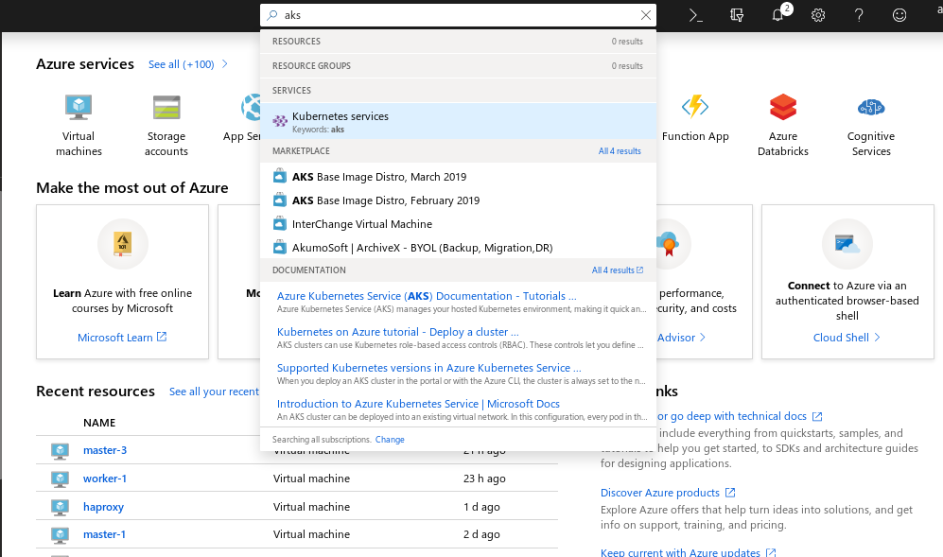

**2. Click on create Kubernetes Service** 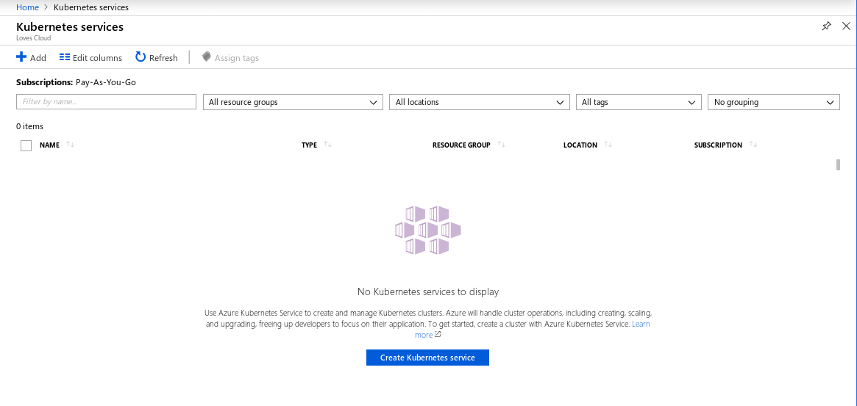

Enter **Kubernetes Cluster name:**

Keep following fields as default

**Region:**

**Kubernetes version:**

**DNS name Prefix:**

Scroll down, Under **SCALE** section,

Keep **Node Size** as default

Change **Node Count:** 2

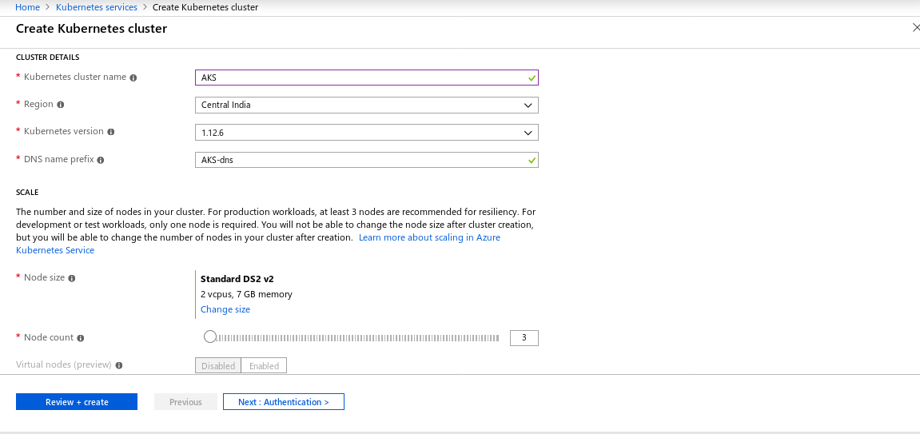

Click on **Next: Authentication**Under **Kubernetes authentication and authorization ,Enable RBAC** NO

Click on **Next : Networking >**

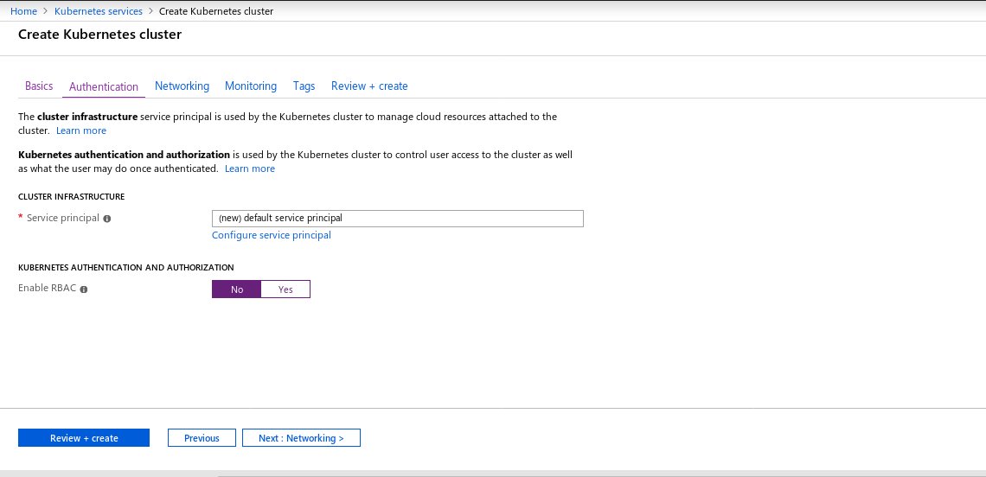

3. Click on **Next : Monitoring >**

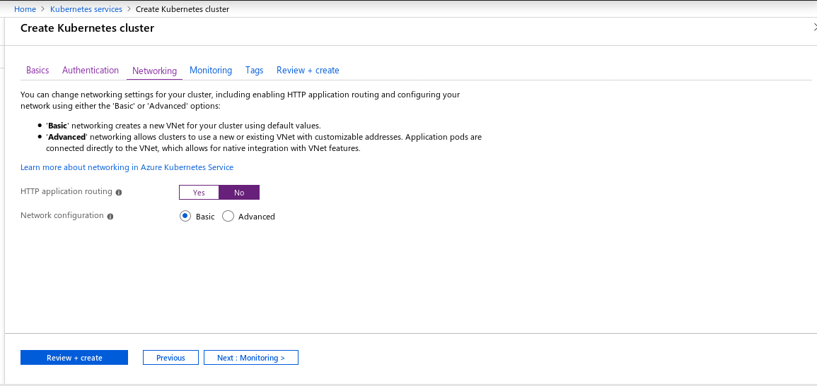

**4.** Keep **Enable Container monitoring :** Yes and Click on **Next : Tags >**

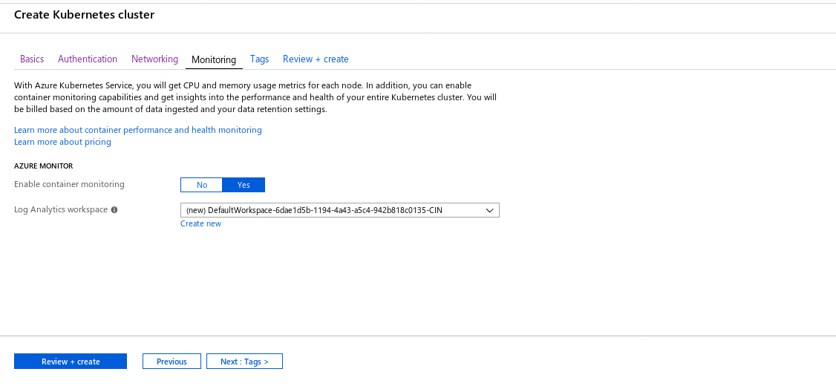

**5.** Add **Tags** if requiredand click on **Review+Create**

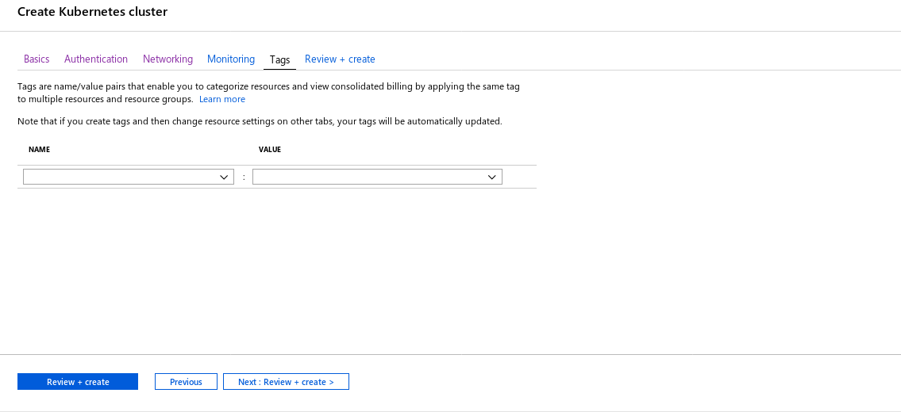

**6.** Once it shows **Validation passed**, Click on **Create**

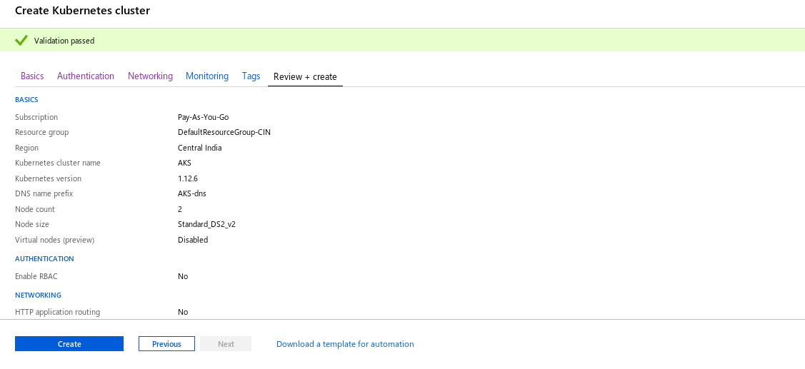

7. Once Deployment is complete, Click on**Go to resource**

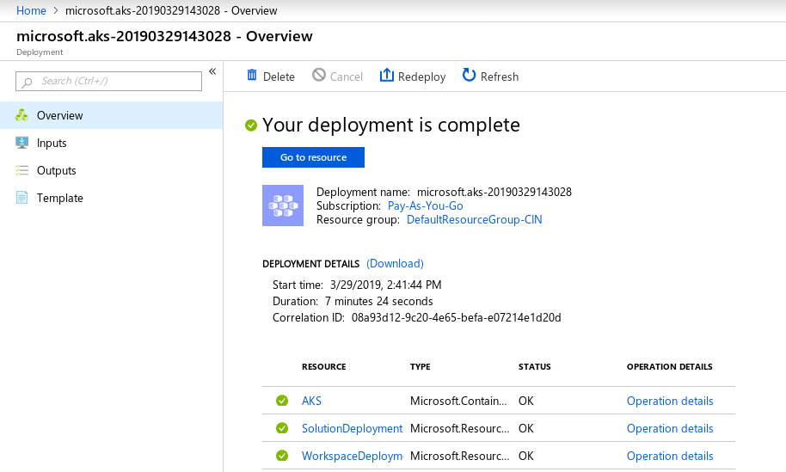

**8. Click on View Kubernetes dashboard**

